September 2018  Tuesday, September 4 | 12:30 p.m.  Marc Teicholz, Guitar  Angela Lee, Cello  - Arvo Pärt: Fratres  - Redames Gnattali: Sonata for Cello and Guitar  - Antonín Dvorák: Sonata in G Major,  Op. 100, B. 183  Tuesday, September 11 | 12:30 p.m.  Eugene Alcalay, Piano  - L. V. Beethoven: Hammerklavier, Op.106  Tuesday, September 18 | 12:30 p.m.  Jessica Chang, Viola  Laura Gaynon, Cello  - L. V. Beethoven: Duet for Viola and Cello, WoO 32, Eyeglasses  - György Ligeti: Sonata for Solo Cello  - J. S. Bach: Suite No. 2 in D Minor for Solo Cello, (arr. for Viola) BWV 1008  - Henri Vieuxtemps: Capriccio for Solo Viola  - W. A. Mozart: String Duo in G Major, K. 423  - Astor Piazzolla: La Calle 92  Tuesday, September 25 | 12:30 p.m.  Florin Parvulescu, Violin  Chia-Lin Yang, Piano  - Francis Poulenc: Sonata for Violin and Piano, FP.119  - Gabriel Fauré: Sonata for Violin and Piano, No. 1  in A Major, Op. 13  October 2018  Tuesday, October 2 | 12:30 p.m.  Memorial Concert for Sue Brown  Tom Stone, Violin  Tanya Tomkins, Cello  Eric Zivian, Piano  - Felix Mendelssohn: Piano Trio No. 1 D Minor,  Op. 49  Tuesday, October 9 | 12:30 p.m.  Broderick String Quartet  Franz Joseph Haydn: String Quartet, Op. 50, No. 3  Claude Debussy: String Quartet in G Minor, No. 10  Tuesday, October 16 | 12:30 p.m.  Hausmann Quartet  - Tina Talon: Selective Defrosting  - Donnacha Dennehy: The Weather of It  - Franz Joseph Haydn: String Quartet in A Major,  Op. 55, No.1 |  |  | Tuesday, October 23 | 12:30 p.m.  Midsummer Mozart Festival Chamber Players  - W. A. Mozart: String Quartet No. 16  in E-flat Major, K. 428/421b,  The Third “Haydn” Quartet  - W. A. Mozart: Piano Concerto No. 12  in A Major, K. 414 (385p)  Tuesday, October 30 | 12:30 p.m.  Jonah Kim, Cello  Miles Graber, Piano  - Johannes Brahms:  Cello Sonata in E Minor, Op. 38  Cello Sonata in F Major, Op. 99  November 2018  Tuesday, November 6 | 12:30 p.m.  Elizabeth Prior, Viola  Miles Graber, Piano  - Johannes Brahms:  Viola Sonata Op. 120, No. 1 in F Minor  Viola Sonata Op. 120, No. 2 in E-flat Major  Tuesday, November 13 | 12:30 p.m.  Christina Mok, Violin  Max Bragado-Darmen  - L. V. Beethoven:  Sonata No. 6 in A Major, Op. 30 No.1  Sonata No. 7 in C Minor, Op. 30, No. 2  Tuesday, November 20 | 12:30 p.m.  Alisa Rose, Violin  Michael Graham, Cello  Amy Zanrosso, Piano  - Alisa Rose: Trio for Luisa  - Dmitri Shostakovich: Piano Trio No. 2,  Op. 67 in E Minor  Tuesday, November 27 | 12:30 p.m.  Joseph Gold, Violin  Jaume Torrent, Guitar  - George Frideric Handel: Violin Sonata in D Major, HWV 371  - Jaume Torrent: Summer Nights  - Franz Schubert: Arpeggione Sonata, D 8  September 23 / October 21 / November 18  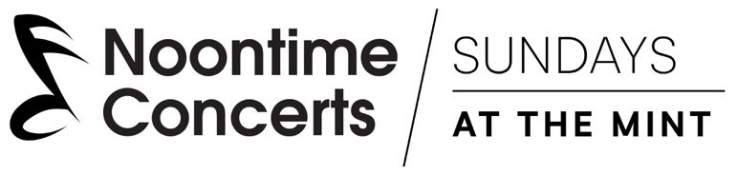  http://noontimeconcerts.org/sundays-at-the-mint

